**Vector Based Drawing Application**

**Made by:**

Ahmed Reda Amin Selim.

Gamal Abdelhamid Ghanem

# Contents:

1. UML Diagram.
2. Design.
3. GUI and Snapshots.
4. User guide.
5. Decisions and Assumptions.

## UML Diagram:

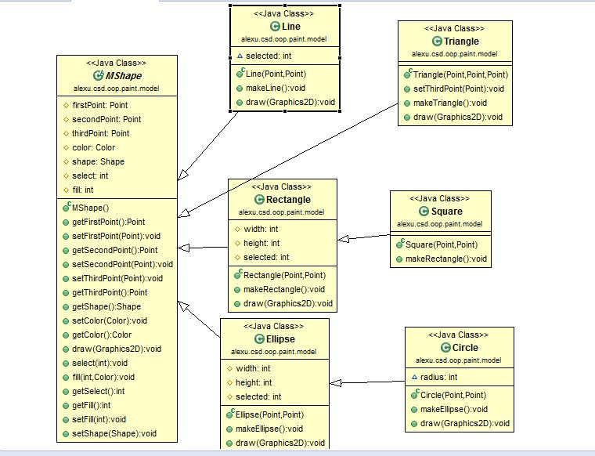

## Design:

The project includes 5 main parts:

1. **Geometric shapes and data model:**

In this part an abstract class is created to include the common properties and functionalities of different shapes like the center point, a second point to draw the shape, colors, fills, graphic 2D shape, getting and setting methods for these attributes and drawing method. In addition to the properties and methods provided in the shape class, every geometric shape has some properties and methods that are not existed in the other shapes. So another six classes were created for the different shapes (Line, Rectangle, Square, Ellipse, Circle, and Triangle). Each of these classes extends from the parent shape class with some additional attributes and methods.

Line: it has neither additional methods nor attributes as it is defined by only the start and the end point.

Square: it extends from the rectangle as it is different from the rectangle that its width and height are equal.

Rectangle: it has some additional attributes like the width that is essential for drawing the shape, the height and getters for these attributes.

Ellipse: it has additional attributes like minor axis and major axis that are essential for drawing it.

Circle: it extends from the ellipse as it is only different from the ellipse that their major and minor axes are equal.

Triangle: it has additional point as an attribute and setters and getters for this third point.

1. **View model:**

This part controls the connection between the components used to make a good interface and data model we have just discussed. All the inputs of the data model are passed by mouse actions and the results are displayed immediately on the draw area of the application. This model contains 4 main classes:

1. Draw Bar class: occupies the left part of the screen and contains buttons for drawing and painting.
2. Tool Bar class: occupies the upper part of the screen and contains buttons for saving and loading the work.
3. Draw Area: occupies the big part of the screen and controls the action of the mouse to draw and edit in the shapes by storing the shapes in an ArrayList and repainting this list with every new action.
4. Main Class: make instances of the other models and organizes the requests and responses among the previous parts and the user.

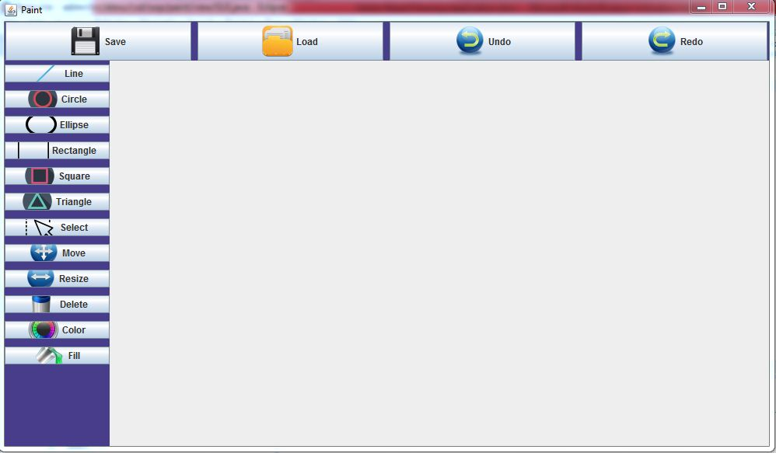

1. **Editing:**

In this part you can edit in the drawn shape by deleting, moving, resizing, or coloring it in a user friendly way.

1. **History model(save, load, undo, redo):**

This part pushes the list in a stack with every action regardless of the action is adding a new shape or editing in an existing one so you can undo until the start state of the program and redo all these steps again.

It also controls the process of saving your work in your computer and loading it again whenever you want.

1. **Dynamic Application Extensions and Plug-ins:**

This part enables class loading option so u can load classes for non existing shapes at runtime and use them like the original ones.

## GUI and Snapshots:

Simple drawing

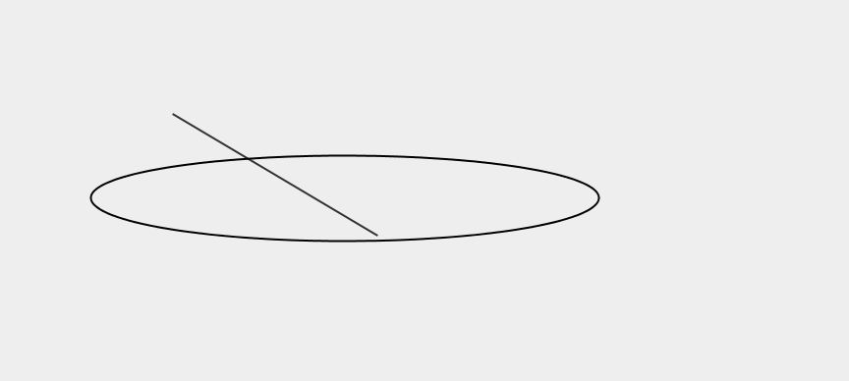

Selecting and coloring

Filling the ellipse

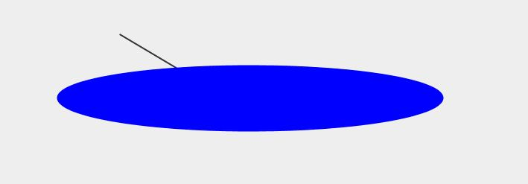

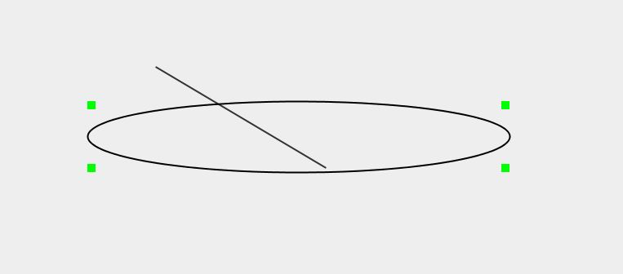

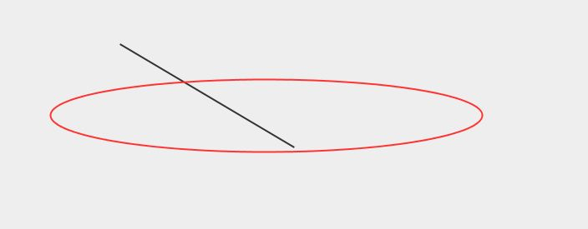

## C:\Users\MR\Desktop\first GUI.jpgSample snapshot

## User Guide:

***Drawing***

You can draw any of the listed shapes by clicking on it then moving towards the drawing area to start. Click once at the point you want to be the starting point of your shape. Then move the mouse freely and you will see the shape dynamically changes with motion so continue moving the mouse until reaching the required dimensions. Finally click once to end the process.

*Note that:*

1. The starting point changes from one shape to another,

For rectangles and squares: the starting point is the upper left corner.

For circle: the starting point is its center.

For the ellipse it is the upper left corner of the surrounding rectangle.

1. While drawing the triangle, you need to click once for every point and you can start by any point of the three.

***Editing***

**Select:** Before applying any of the editing options you must firstly select the shape you want to edit by clicking on select button then clicking once inside the required the shape.

**Move**: after selecting the required shape, click at the starting point of the shape and hold the moving until the destination thenrelease the click button.

**Delete:** just click on delete button after selecting the required shape.

**Fill**: click the fill button and choose your preferred color from the color chooser.

***Undo and Redo***

Just click on click the buttons and everything will be wright.

***Saving and Loading***

There are two types of saving and loading: json file saving and xml file saving and there are corresponding buttons for each. So you should click the required one then choose the destination from the file chooser.

The loading operation requires clicking the load button and selecting the file type then choosing the file you want to load in you program.

**Decisions and Assumptions:**

* It was decided to make the square and the circle classes extend from the rectangle and ellipse correspondingly as the only difference is that the minor and major axes are equal for each.
* It is assumed that all data input will be through the mouse action, no dialogue boxes or text fields were used.
* Resizing is applied by changing the last input point(like the bottom right corner for the rectangle)
* Moving the shapes will be controlled by the starting point of the shape

(You can understand the meaning of the start point from the design part)